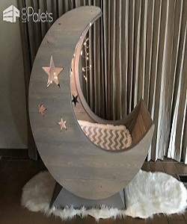

Baby Cradle

$114.37

Availability: In stock

Description:

Laying in the Lullaby Crib calms your newborn and swings your baby to sleep. Quite a comfortable way to get used to the world! Handmade with wool cotton and bamboo. This swing crib comes without a mattress. This is because the of a mattress is very specific per person. We choose to let our little ones sleep on sheepskins. The comfortable cushioning of the headboard gives your baby body all the support needed to sit and relax. Available in multiple colors and sizes.Solid wood have inherent natural colors and variations that present a number of beautiful possibilities for your room.Our wood come in a wide range of stylish variations, including cherry, hickory, maple, birch and red oak.